**Subject: Artificial Intelligence (DJ19DSC502)**

**AY: 2023-24**

**Experiment 8**

**(Fuzzy Logic)**

**Aim:** Design and Implement a Fuzzy Logic Controller.

**Theory:**

A **fuzzy control system** is a control system based on fuzzy logic—a mathematical system that analyzes analog input values in terms of  logical variables that take on continuous values between 0 and 1, in contrast to classical or digital logic, which operates on discrete values of either 1 or 0 (true or false, respectively.

Fuzzy logic works on the concept of deciding the output based on assumptions. It works based on sets. Each set represents some linguistic variables defining the possible state of the output. Each possible state of the input and the degrees of change of the state are a part of the set, depending upon which the output is predicted. It works on the principle of If-else-the, i.e. If A AND B Then Z.

Suppose we want to control a system where the output can be anywhere in the set X, with a generic value x, such that x belongs to X. Consider a particular set A which is a subset of X such that all members of A belong to the interval 0 and 1. The set A is known as a fuzzy set and the value of fA(x) at x denotes the degree of membership of x in that set. The output is decided based on the degree of membership of x in the set. This assigning of membership depends on the assumption of the outputs depending on the inputs and the rate of change of the inputs.

These fuzzy sets are represented graphically using membership functions and the output is decided based on the degree of membership in each part of the function. The membership of the sets is decided by the IF-Else logic.

### **Fuzzy Control System**

A fuzzy control system consists of the following components:

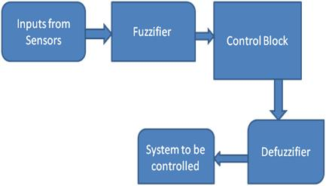

**A Fuzzifier** which transforms the measured or the input variable

**A Controller** performs the fuzzy logic operation of assigning the outputs based on the linguistic information. It performs approximate reasoning based on the human way of interpretation to achieve control logic. The controller consists of the knowledge base and the inference engine. The knowledge base consists of the membership functions and the fuzzy rules, which are obtained by knowledge of the system operation according to the environment.

**The Defuzzifier** converts this fuzzy output to the required output to control the system.

**Lab Assignment to do:**

Design a fuzzy Logic Controller to set the time of a washing machine.